

School of Science and Technology

COMP40721
Foundation OF ARTIFICIAL INTELLIGENCE

by
Pratham Amit Shah
N1364759

Introduction-:
At GlobaTech , as I have been assigned as a new Data Scientist where the work force is mostly driven with all around the world’s HR firm and multinational data analytics organisation that resolve the global market place for salary distribution approach.
Company recently accepted the early salary survey dataset for the year 2024 which typically consisted of number of survey’s recommended on reference of asking the priority manager. Salary dataset was typically collected of all the professional working people across the globe that consist of unique features as follows-:
- People’s Age
- Gender
- Race
- Industry Specialisation Name
- Number of Experience in various field
- Other Education background qualification.
Core relatively the issue manager Dr .Emily Carter, shared is to classify the salary of all the employee’s based on the dataset with multiple attributes and so as to build the algorithm that will portray the salary as well as it should identify their income amount under a set of provided range that will define the salary of that employee in exact that option. Due to vast range of Entries in this dataset that self explains that it will include many of the numeric missing values, multiple outliers and entries that will surely affect the model accuracy, which will make sure before successfully building the model and my manager provided me with the income range which is written below-:
- Low Income Tier-: <= 70,000 USD
- Medium Income Tier-: > 70,000 USD & < = 100,000 USD
- High Income Tier-: >100,000 USD

Analysis of Salary grouping-:
Optimally to regulate the individual income based on social and professional unique values impacts a crucial role in finding the value of salary that has been allotted to us. The concept of Tier classification is clearly an ideal choice that will help to find the salary with additional source of amount attached with salary termed as ‘Compensation’. Prediction of the salary is considered to be dynamic benchmark in gathering the pay out of person and additionally helps the GlobaTech company to make the decision against the workforce very accurately.

Realistically understanding the depth of the modelling in salary prediction I preferred to choose the CRISP-DM ( Cross Industry Standard Process for Data Mining) Program. It consist of various building blocks such as: Domain Knowledge , Grasping of Data , Authentic Model , On-setting of the model. We have used this approach to make sure we get the outcome of our model attached with the principle of business idea by GlobaTech .

Analysis of this report is fundamentally covers each step of CRISP-DM thoroughly which includes the explanations of required data, technology carried to demonstrate the model, result of regression as well as classification models.
0.713 % is been capable for deployment as outcome result for better understanding of data with recommended value.

2 Exploratory Data Analysis-:
Approach of EDA is said to be one of the most important factor for analysing the format of data that has been provided in the survey and participation of all the variables in it. EDA enables the regulative understanding of the data which is co-related to professional workers and also is equally focused on development of social culture of the people. Survey dataset is mixture of various attributes which includes -:

- Name of the Industry -: Regional information of industry people working in.
- Age-: Participant’s age data
- Functionality of the job-: Participants actual job role based on skills
- In-depth info of position-: It clarifies the extra information if needed for the job role
- Income-: Yearly total payout based on working for worked the job forty hours a week, 52 weeks a year
- Reward/Bonus -: Separate source of income attached such as incentives, extra time.
- Currency -: Type of currency which is allotted based on data provided.
- Foreign-Currency-: Multiple various currency which is preferable typically by the people.
- Additional info on income -: Information which can be used for extra knowledge of the income assigned.
- Location of work –: Specify the area of place you work is used in this column.
- USA States name-: Column used for all the cities which are possibly in this country .
- Place of deployment/location-: Area or peripheral of work.
- Option of work-: It is column data which differentiate on what sort of working place is assigned eg remotely accessed or at present site job etc.
- Job arrangement -: It specifies the setup of job.
- Track-Record-: Justifying a set of number that is linked to experience of that person.
- Qualification -: Information of level of skills/study education needed for it.
- Gender-: Information of human-being is mentioned in this column.
- Race-: Providing multiple caste around the world.

2.1 Process of cleaning the data and Preparing for model -:
To initialised the data for modelling we have implemented first renaming of all the columns for better understanding of data with cleaned name and demonstration of data. Renaming of data has been performed with the function named “df.rename (‘Enter whichever column required’)”. This enables the data to be easier to use as the bulky sentence of column have been converted into short easily understandable pattern , as the cleaning methodology is on the go and achieved it is important step to individually monitor each column and to know what method is best to use for updated column data with highest accuracy.
Understanding the data to be handled and variety of data , we have to use as per the type of data provided which contains numerical, categorical and also mix of text formats. Ideally I have implemented looping statement of “For” statement for converting and cleaning the categorical values which typically is best approach compared to K-means algorithm and the reason is quite reasonable as k-means algorithm provides me the data with random output which is not helpful in accuracy modelling. So fulfilling the cleaning of categorical column data with help of ‘for looping’.
Looping is attempted in such a way that we start with getting the first ten unique values of the particular column and after getting that we group them in four variables concept that will include directories we got into that variables for instances-:
We took the column which states the industry of the employer and got the input as shown below
- Education (Higher Education)
- Nonprofits
- Government & Public Administration
- Computing or Tech
- Health care
- Accounting, Banking & Finance
- Education (Primary/Secondary)
- Galleries, Libraries, Archives & Museums
- Manufacturing
- Law
- Biotechnology & Pharma

Now, as mentioned unique values these are all containing multiple data entries of employee so in order to remove multiple error values and missing values we will be allotting them into variables which we created as follows-:
Education/tech =['Education (Higher Education)','Education (Primary/Secondary)','Engineering', 'Computing or Tech' ,'Aerospace & Defense']
Gov/manufacturing =['Government & Public Administration', 'Manufacturing' ,'Galleries, Libraries, Archives & Museums']
Media/healthcare =['Health care',' Utilities & Telecommunications' ,'Media & Digital']
Marketing = ['Marketing, Advertising & PR']
df['cleaned_industry']= ('Other')
As per the code all the entries will be assigned in the variables and which ever are the enteries that exclude from the mentioned value will be directly transferred to ‘others’ section.
I have taken this approach of grouping in result to get the model accuracy preferably better and also the prediction of the salary will be easier in order to place. We have used this particular concept in many other columns which are
- Functionality of the job i.e column named as (“job_function”)
- (“Gender”)
Particularly for the case of data columns where the data are in the form of numeric values. I have implemented the function named ‘df.replace’ . Using this function it will choose the highest value between that variables and that value will be set for that set of number. In order to understand more about how this function works and how it is implemented let’s see it in as an example We have chosen the column where the age group varies from
- 35-44
- 25-34
- 45-54
- 55-64
- 18-24
- 65 or over
- under 18

- Location/workplace-: Using the same concept we have implemented to group all the working countries as well where we have grouped them in multiple country groups which is mix group of USA, Canada, United kingdom, Ireland, Oceania That have Australia and New Zealand in it and western countries and last but not the least Japan.
- Qualification-: In a similar pattern we have implemented the grouping function with combined use of “for and loc” function in education column as well with creating three new variables which includes the unique values which were printed in the first output and those output where organized in three categories and any other value which are out of this category are considered to be transferred in others.

In order to understand this age values we will be using the highest value of that range and that will be set for that particular age limit and it will be easier after the data has been cleaned. We will be implementing this by creating a new variable that will store all the new values of that age range which we will be providing and that’s how the column of age is cleaned with numerous value numbers and there are multiple columns which contains only numeric values or nan values which are cleaned by the same concept of allotting the particular group of numbers into highest limit assigning in a new variable as a new column that will be easier when model prediction is done.
Numeric other columns which use the same concept as previous age column data are as follows-:
- Track-Record-: The column track record contains various set of number ranges which are termed to be the list of years of experience which are in the range below mention
11-20 years , 21-30 years , 8-10 years, 5-7 years, 31-40 years , 2-4 years , 41 years or more.

- Field Experience-: This is the similar example compared to the above one but the only concept which changes here is the total number of experience which is based on primarily on the way the employer works in what particular field and for how many years they have worked there.
To begin with cleaning the data of the column race we have opted if else looping statement because the values in the race column includes multiple comma text and to clean that values which have multiple missing and text values we have used function symbol “ comma “, This function will make sure in the if else statement which will be stated if the value of the race contains a comma It will be considered as different value or else the value which is in a single line and doesn’t have any, will be considered a unique value and it will be printed like that. To understand more about it I have mentioned the code below of it
def cleaned_race(race):
if ',' in race:
return 'Multiple Races'
else:
return race.split(',')[0]
df['cleaned_race_column'] = df['specify_race'].apply(cleaned_race)
Based on the above code the data cleaning of the column race have been done and likewise all the values of the race have been updated and implemented.

2.2 Conversion implementation of Currency and Foreign Currency-:
In the review of Cleaning the data column currency The first task which arrived is to use the iteration symbol “I” and with that the loop statement for and if-else. The cleaning will be done in such a way that the code runs with iteration that will include the salary and currency of that column after that whichever the salary is in currency USD will be transferred to USD or else all the other currencies which are Multiple unique currencies will be converted to the USD currency with real time conversion rates and that’s how the conversion of the currency will be made.
The term foreign currency is considered to be the currency which are different from the existing required USD but it also comes with multiple text values which are similar to the currency but they aren’t considered to be currency so to deal with such error text messages that are mentioned in the data to clean this text format error and nan values we will be putting this nan values in a function name none that will be run by “df.log” and “is. In” function.
After replacing all the text messages or the missing values or the nan values or simply the numeric values with the function we have gathered the output with the unique currency but these currencies are multiple different one and to make sure that our data gets the perfect accuracy we have to convert this currencies as well in the USD currency which is required. Replacing of the currencies was one part of clearing the foreign currency column data but to remove the None values or negative values or the zero value in the currency table we will be using the function that states the condition as “df = df[df['new_currency_usd'] > 0]”. Accurate decision of the currency will be judged by data cleaning and thereby we Have used the function dropna that terminates all the nan values that have been stored

3 Cluster Analysis
As the process of grouping all the columns into cleaned one and utilizing them in the formation of clusters is the agenda of this module. Method of clustering will be divided by algorithm which are as follow-:
- Agglomeractive Hiearchical Method

Primary purpose of using agglomerative hierarchical method is the biggest factor which is this method of algorithm aligns with the provided data set and its more effective on combining the observed value ,also the natural phenomena of splitting the variables occur pretty effectively in this algorithm. The advantage of mixing of clusters and to switch between those clusters is preferably better one on this algorithm and most importantly each of the clusters which are separated are strong enough.
Salary survey data set of 2024 is an ideal way to test these above 2 models that will predict the accuracy and the output.
The code which Determines the grouping of the salaries under three categories names low Medium High which have the salary range of 0 , 70 000 and 1,00,000 as mentioned is
df['grouped_salary'] = pd.cut(
df['new_currency_usd'],
bins=[0, 70000, 100000, float('inf')],
labels=['Low', 'Medium', 'High']
)
df['grouped_salary'].dtype
df['grouped_salary'] = df['grouped_salary'].astype('category')
print(df['grouped_salary'].unique())
print(df['grouped_salary'].isna().sum())
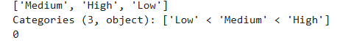
We have taken a new variable named “group salary” that have the range of 0 to 70,000 to 1,00,000 that will define the salaries in the labels of low medium high and the new variable named group salary will be used with the “function astype” and this function is responsible for converting the categorical data with user friendly use After that the values which we get will be cleaned and all the values will grouped up with the function named “isna().sum())”.

K means algorithm is beneficial for using and predicting the data which have limited unique value and features and we have applied the algorithm with two column names
- Mode of work
- Company unionised
The advantages of using the agglomeractive clustering on given two columns is that they contains values which are countables one and so they are perfect dataset to use with this algorithm.
from sklearn.preprocessing import LabelEncoder
from sklearn.cluster import AgglomerativeClustering
df = df.dropna(subset=['hybrid_on_site'])
le = LabelEncoder()
df['mode_encoded'] = le.fit_transform(df['hybrid_on_site'])
hc = AgglomerativeClustering(n_clusters=4)
df['Cluster_hirearchial'] = hc.fit_predict(df[['mode_encoded']])
print(df[['hybrid_on_site', 'mode_encoded', 'Cluster_hirearchial']].head())

This algorithm consisted of two libraries which were imported from sklearn pre-processing and sklearn cluster that imports label encoder and agglomeractive clustering as well and the code begins with importing both of the libraries. Firstly, label encoder is a function which helps the systematic text options to transform into multiple variable codes. For example remote, on site, of site, hybrid. On the other hand, the clustering method agglomeractive is used for a set of combined data clustering with the function named “dropna”. It is helpful for dropping all the values which are none because while performing the clustering, it is negligible to keep the nan values as it cannot manage to handle that that’s why we will be removing after importing and removing the nan values. The function fit transform will come into play and that will read the text of the column which we have inserted, and then based on that the option of clustering inserted as four which includes four options based on that the function fit predict will predict the algorithm of the cluster and based on that the value will be shown as 0, 1, 2, 3
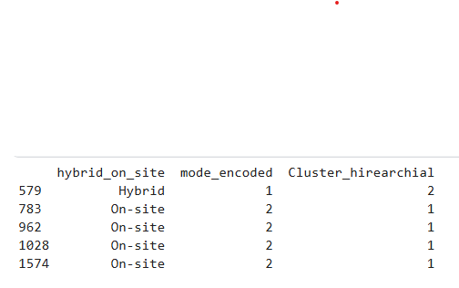

Similarly the same algorithm is applied on the category of job unionized and the output of that category is shown below-:
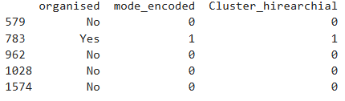

4 Machine Learning Modelling-:

4.1 Start to workflow of the model-:
Operation of building a machine learning model was designed to build a powerful secure classification model which can easily classify the category ‘grouped-salary’ despite of all the multiple factors/variables attached with the survey data

Preparation of model with flowing mechanism of the model and how accurate it will work is made below-:
Cleaning & Selection of Data Decrypting Categorical Values Concept of Train/Test
Split

Opting for Ideal Model Hyperparameter Tuning Simulating model
construction
Evaluation on working performance of the model

4.2 Selection and justification of Feature-:
The theory of predicting the salary with the desired features that are age, working division of the employee, what type of work mode he chooses ,every sort of organisational types ,number of experience the employer have infield as well as total number of experiences based on working skills, what sort of gender and based on qualification and last but not the least the generic race is how the feature selection has been done.
All the above features which are linked to the model are connected to the problem statement, which was provided to me and it regulates with the outcome of the model very accurately. Advantages of utilising three learning models makes the rigid version of the model prediction as in case any one of the model outcomes gets weak is covered by other two strong building model for the data.

4.3 Ensemble strategy and Theory behind it-:
What is the reason behind using a voting classifier “Hard Voting “?
- Better performance when used with combined models.
- Neglects the barrier between linear & Non-Linear separating line.
- Provides outcome based on classifying all major features of models.
- Improves the negligence caused by decision making of tree.
Classification of choosing the three models helps to improvise the prediction of the salary with better generalisation of the category and it increases the rigid which arrives due to unpleasant data and also a clear aspect of result based on three models and local patterns Nevertheless, as there are multiple advantages, there is a drawback of using a combined model rather than preferring a single model selection and the drawback is while optimising. The three model selection. It reduces the predictability of the model and raises a concern with higher demand on concept of computational analysis. We have implemented the “solver = lbfgs “ which is usually applied for generally maximal clarity when using unique classification , not just that but function named max_iter was kept to 10000 to achieve the data with as many complication as it wants. Utilising K near neighbours, make a balanced exchange on the bias and variance and nevertheless other methods named cross/validation , adjusting depth search tree may improve the performance of model if chosen but used model ensemble showcases the result very effectively.

4.4 Final Evaluation of Accuracy-:
Testing & Training of the classification model ensures the optimisation of the accuracy.
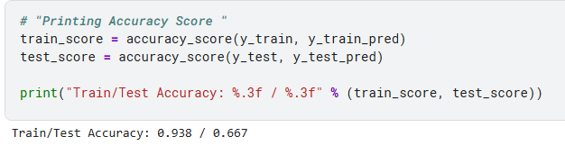

5 Implementation of Random Forest Regressor-:
Based on solving the required question which is this
“Which factors most strongly influence annual income globally?”
The aim of using the random forest regressor for the outcome of salary is because it is useful while predicting the output with numerical values, and in this case, random forest regression is an ideal predictor to get the values with the mentioned features. Random forest regression is easier to use for handling the data which contains non-linear as well as relationships which are complex and in this case, many of the features were related to it based on the pattern of the features that contains numerous text and mix numbers. It is an ideal choice to predict the salary through regressor.

5.1 Preferred Factor for Regressor-:
Random forest regression is easier to use for handling the data which contains non-linear as well as relationships which are complex and in this case, many of the features were related to it based on the pattern of the features that contains numerous text and mix numbers. It is an ideal choice to predict the salary through regressor. Based on the code required for the random forest regressive, the option of choosing the trees were kept at 300 and the reason being higher the trees higher the stable prediction and it also makes the model reducing variance, thereby it amplifies the reliability of the features which are important. As selection of fitting, the random forest model has been done thereafter feature extraction is initialised through “rf.feature_importance”
To visualise the data and features which are highly influential and those which are least influenced to predict the salary are plotted and the plot is mentioned below that clearly demonstrates the highly rated feature as well lowest feature.
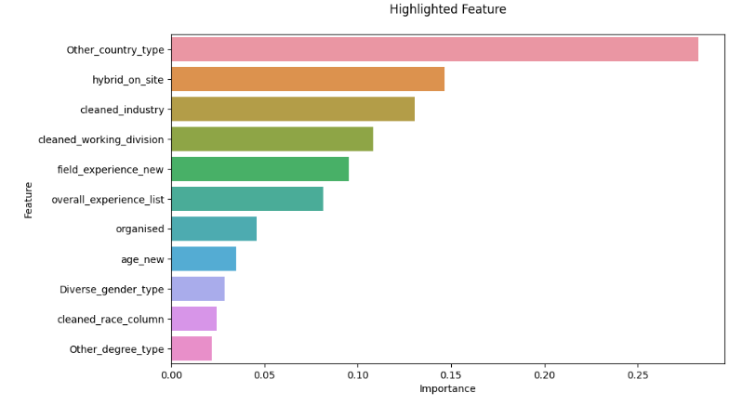

6 Implementation of Random Forest Classifier -:
Supervise machine learning model which is named as random forest classifier is optimised for predicting salary range which are low medium and high based on multiple attributes which are connected with the data set that includes the person, gender, race, age, its qualification background, and features related to its job sector.

For authorising the evaluation of the data to be fair, the data has been splitted into the section of 70% and 30% which are categorised into training and testing Sections
Due to the rigid data provided in the data set which contains outliers of none values or missing values, it’s a very common issue which is faced while predicting the salary into the groups but using the random forest classify, it is easier to predict as it improves both of its error very easily which are linear and relational errors and most importantly, random forest classify contains and in-house feature of its own which allows the data engineer for knowing which attributes and features are highly influenced for predicting the salary.
Classification of predicting the salary based on gender is utilised by the two important function mean and median. Mean is used for predicting the overall distribution of the salary which will be reflected and median is used so that it helps to minimise the output with the influence of the outliers/missing values which might appear and together it provides a sturdy model prediction pattern. For demonstrating the plot and visualisation, numpy array is started for presenting the position of x axis in the bar chart using the mat plot lib. The median salary column is plotted, and the table of mean is stacked. This image of plotting clearly showcases genders and how they differentiate between mean and median.
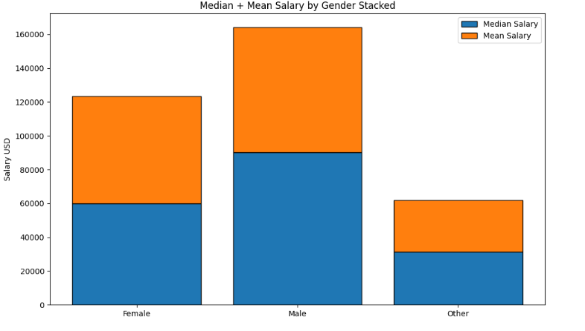

7 Results and Discussion-:
Discussion of the performance based on random forest classify which have predicted the salary category under three names as low medium and high. It includes the key features containing the accuracy. Precision recall and F1 score, thereby to make it understand easily. A confusion matrix has been mentioned below.
Above classification matrix shows what are the predicted labels and what is the actual label count shows the number inside displays the total number of prediction, the label predicted, and the assigned label where.
Classification Report-:
 | Precision | Recall | F1-Score | Support
High | 0.50 | 1.00 | 0.67 | 2
Low | 0.82 | 0.82 | 0.82 | 11
Medium | 0.00 | 0.00 | 0.00 | 2
Accuracy |  |  | 0.73 | 15
Macro Average | 0.44 | 0.61 | 0.49 | 15
Weighted Avg | 0.67 | 0.73 | 0.69 | 15

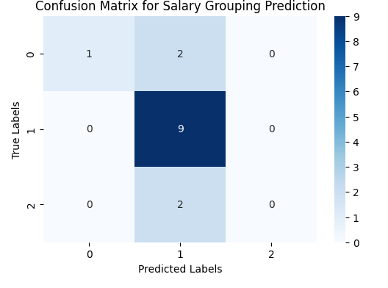

7.1 Discussion on category of model-:
Rate of error comes down to percentage of 27%. As per the F1- score we have gathered 0.69 percent extensively helps to know that model performances is better. My observation claims that in the category of high salary predicted one of two classes have been classified correctly, that means that one of the high in the data set resembles with a pattern based with low earner in a specific industry of its type. As far as it’s about low salary class, the model has predicted 9 out of 11 times perfectly and it shows that the prediction of the lower category have been successfully done. For the category of medium, the model has predicted none out of two cases when applied. In this case, it means that in the category of medium, the prediction has came to low.
Prediction of the model have been working extremely well on the category of low and high, but on the contrary, the drawback of the model is it is not having a perfect modulation of category medium and it appears a bit of a grey area in that. Similarly the salary evaluation between the categories of low and mediums are comparatively a bit inappropriate, making it difficult for clarification, although they were multiple imbalances between the classes of the attributes, but the classification model of random forest effectively completed between the Complex influences as well.

8 Conclusion-:
Ideally, this project investigated the disparities of the salary based on different attributes which were provided and to strongly build a machine learning model that can enhance the income of the person based on multiple attributes provided to it. All the finding of the data were showing the multiple meaningful patterns that clearly makes a difference between genders and also in other categories which are experience fields and their income mentioned categories were good enough for proposing a random forest, classify for out casing the prediction of low, medium and High category of income.
In general, the project aim to gather an accuracy of 73%, which strongly influences between the high and the low category of the salary predicted, but on the contrary that the classification and confusion matrix where creating an error on the category of low because of the poor representation of the data set and because of that, they were grey areas on specifically on the low category of the salary. Nevertheless, the project aimed to offer pretty useful in-depth review of machine, learning methods and providing and key solution for improving the imbalance between the data

